3.44: a) Using generalizations of Equations 2.17 and 2.18, 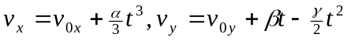, and 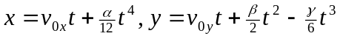. b) Setting 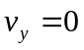 yields a quadratic in 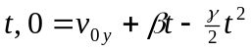, which has as the positive solution
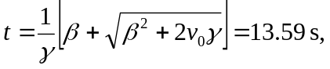
keeping an extra place in the intermediate calculation. Using this time in the expression for y(t) gives a maximum height of 341 m.
c)
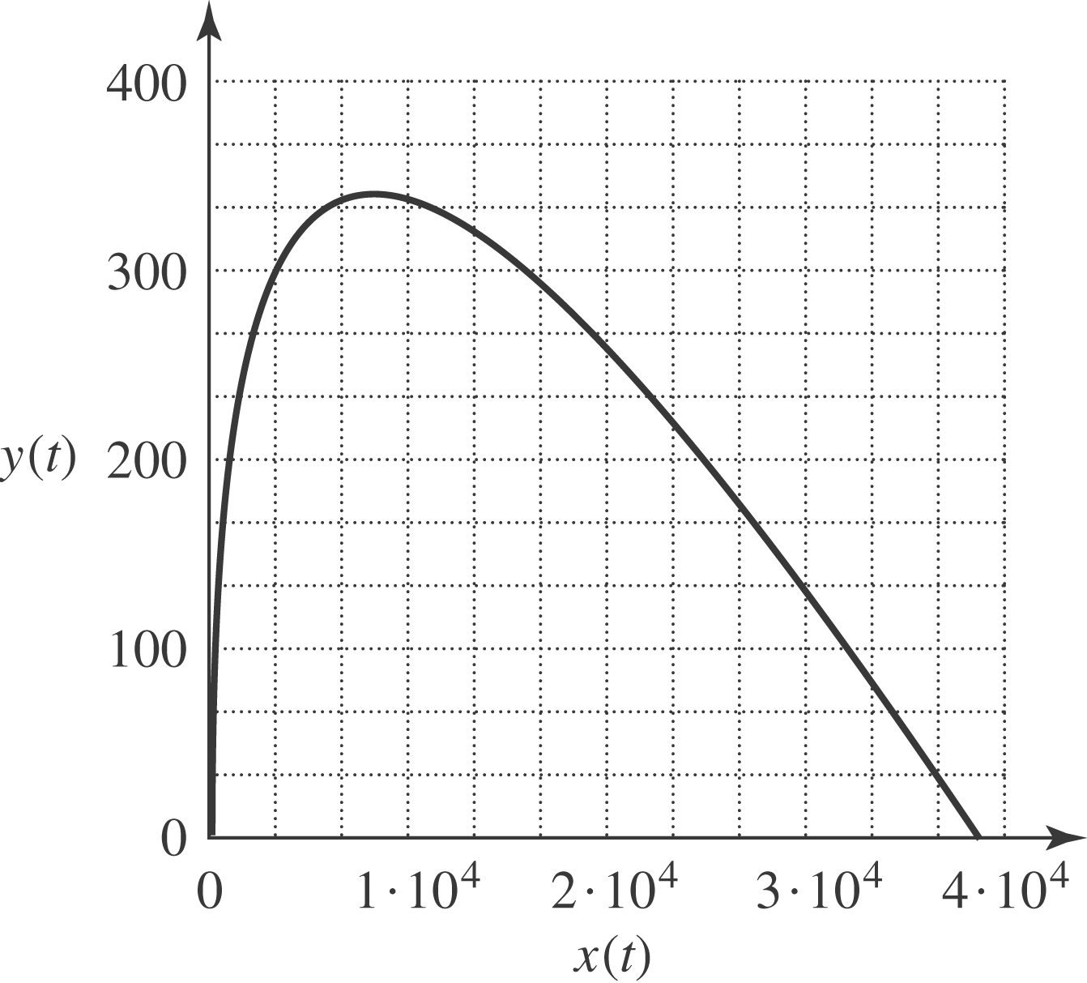

d) The time at which  involves solving another quadratic, 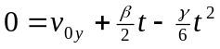 (note that the root 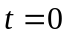 has been factored out). Solving for t gives 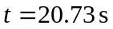 (keeping the extra figure in the intermediate calculation), at which time 

